TASK-3

M INIKUBE VERSION

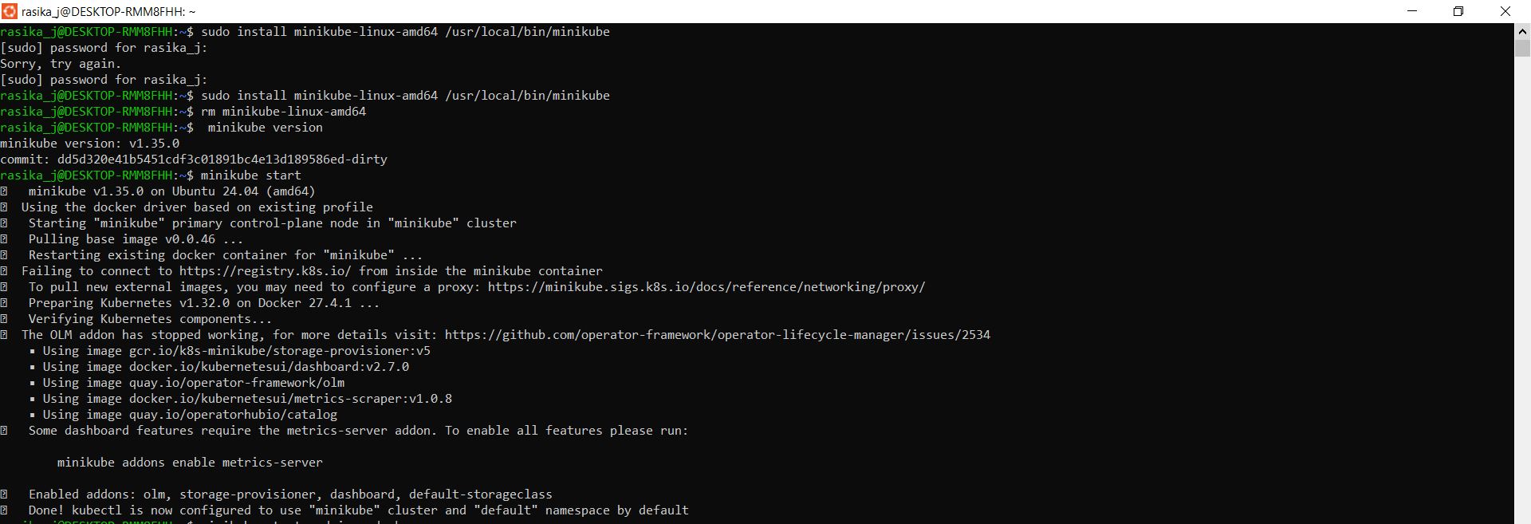

MINIKUBE DASHBOARD



KUBERNETS

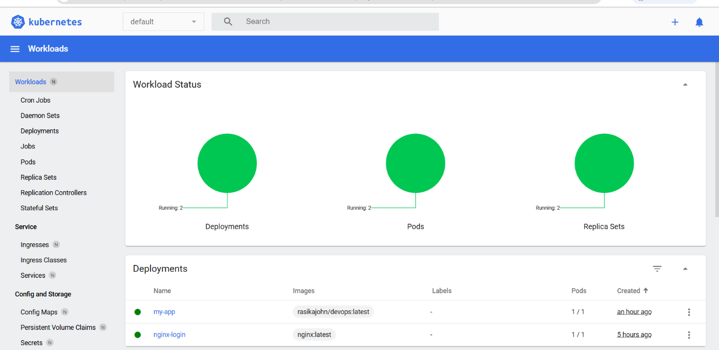

MINIKUBE INSTALL

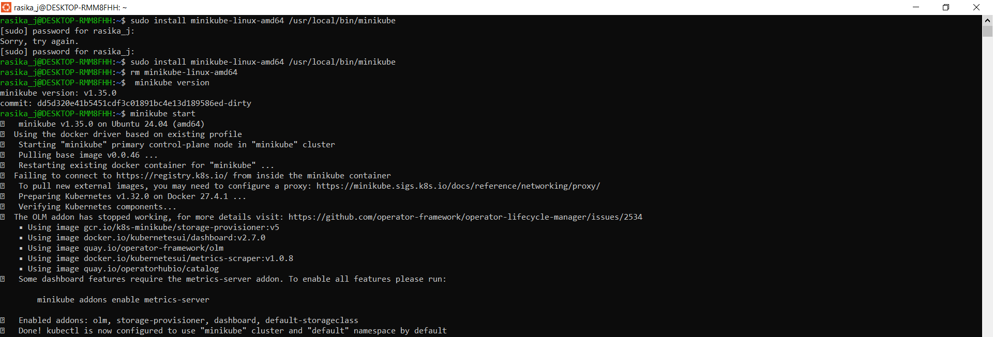

MINIKUBE SERVICE

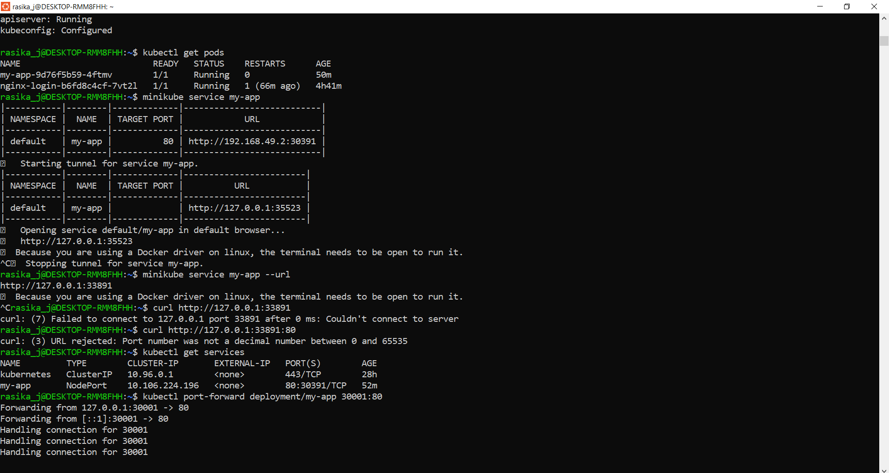

TASK-3 - OUTPUT

